Task on Jenkins-1
1.Install Jenkins and run Jenkins on port number 8081.
- Created new ec2 instances with name Jenkins
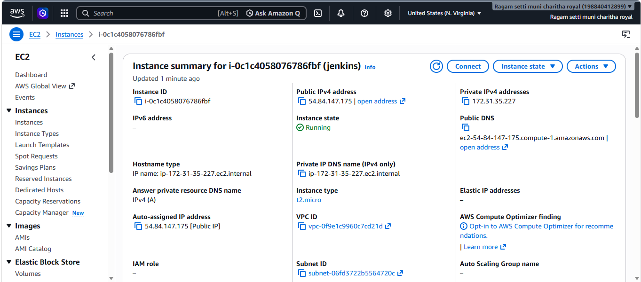
- Ensure that your software packages are up to date on your instance by using the following command to perform a quick software update - sudo yum update –y
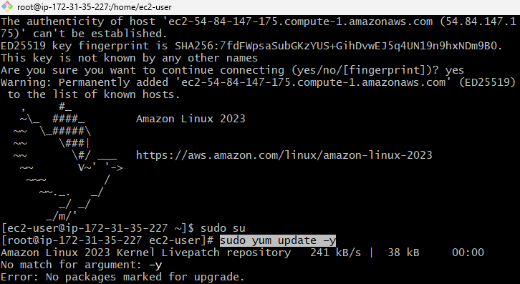
- Add the Jenkins repo using the following command - Sudo wget -O /etc/yum.repos.d/jenkins.repo \ https://pkg.jenkins.io/rpm-stable/jenkins.repo
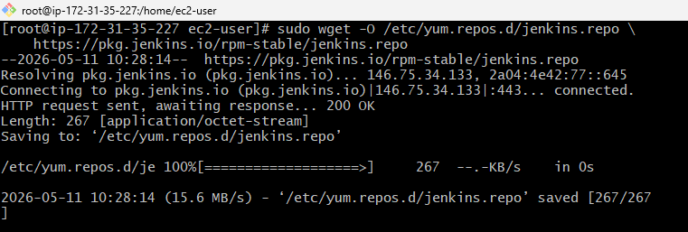
- Import a key file from Jenkins-CI to enable installation from the package - Sudo rpm --import https://pkg.jenkins.io/rpm-stable/jenkins.io-2026.key
- Sudo yum upgrade
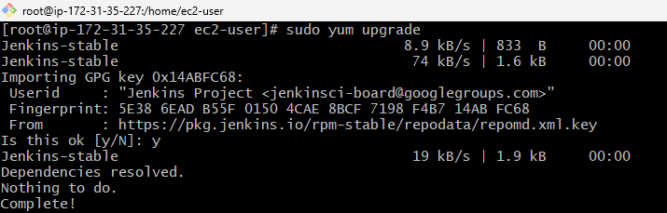
- Install Java - Sudo yum install java-21-amazon-corretto -y
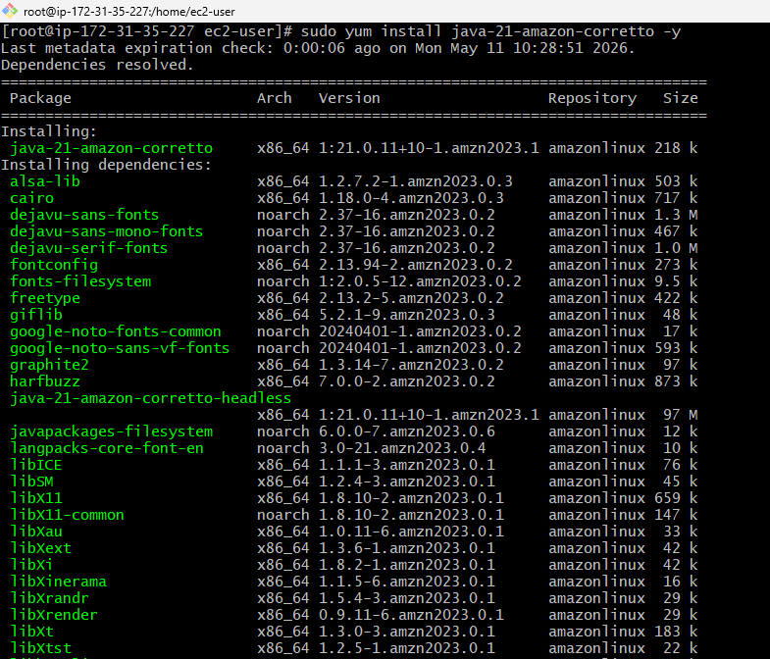
- Install Jenkins - Sudo yum install jenkins -y
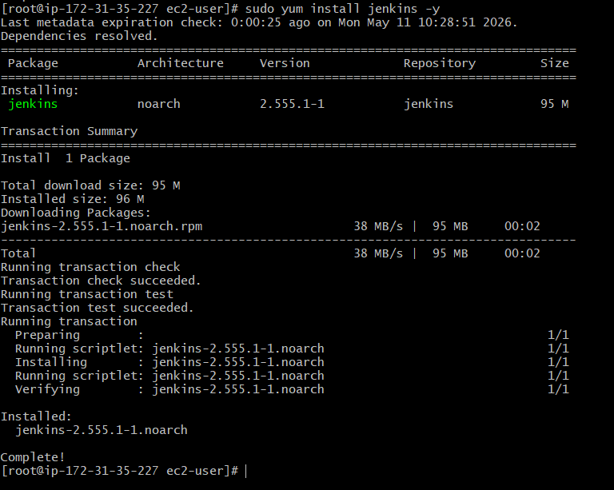
- To change port num 8080 – 8081 we use this command - Sudo nano /lib/systemd/system/jenkins.service
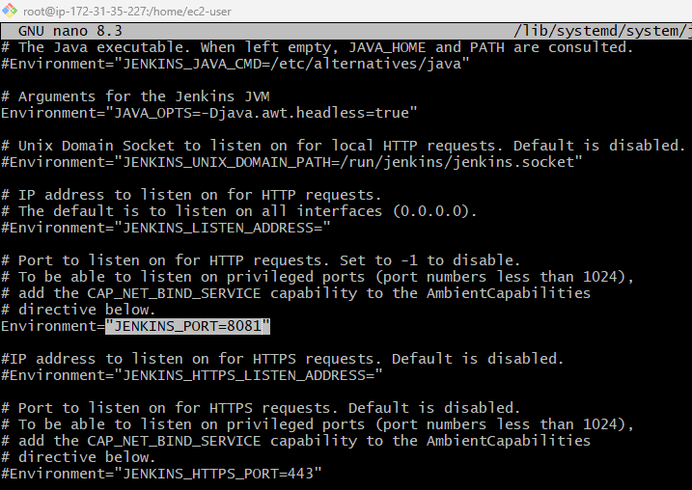
- Enable the Jenkins service to start at boot - Sudo systemctl enable Jenkins
- Start Jenkins as a service - Sudo systemctl start Jenkins
- You can check the status of the Jenkins service using the command - sudo systemctl status jenkins
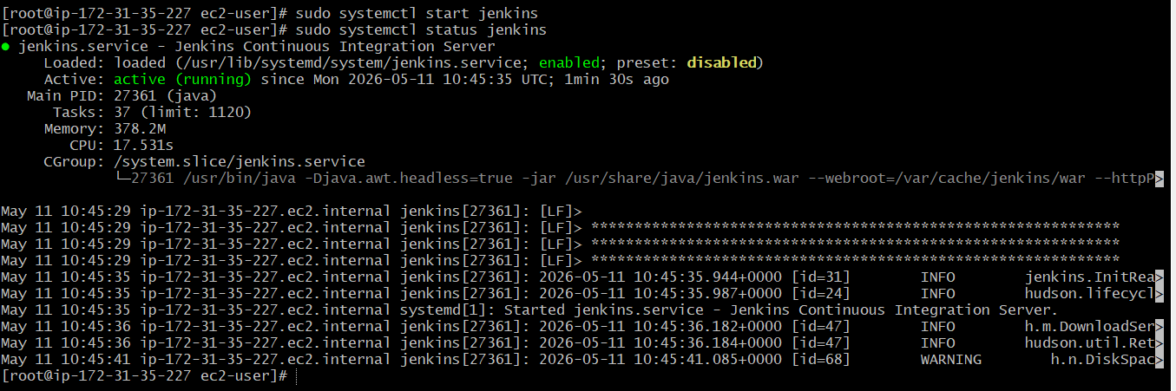
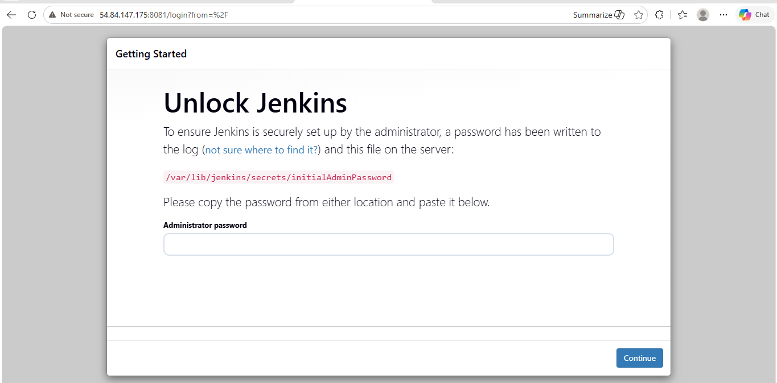
2.Secure Jenkins server
- creating Jenkins admin user
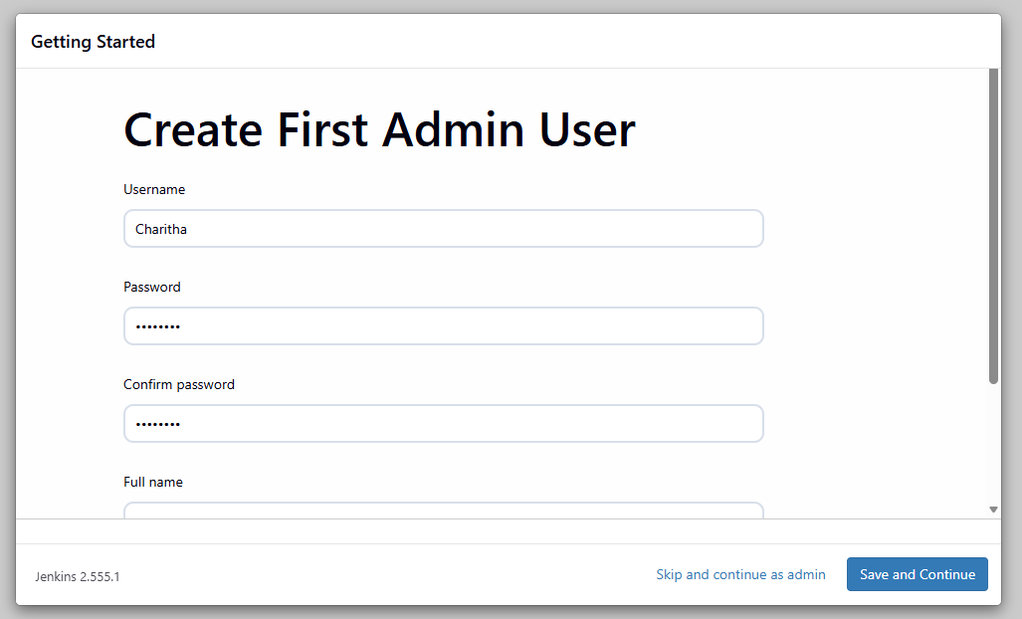
- Jenkins instance configuration was completed successfully by setting the server URL to run on port 8081.
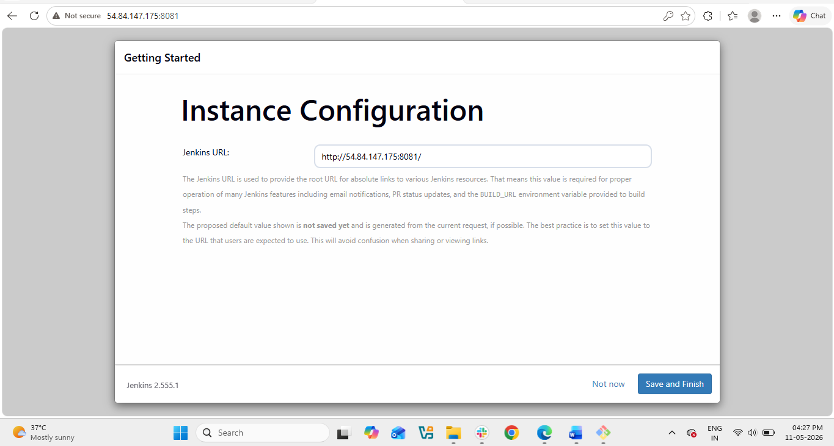
- Jenkins was successfully installed and configured, and the Jenkins dashboard was accessed through port 8081 using the public server IP address.
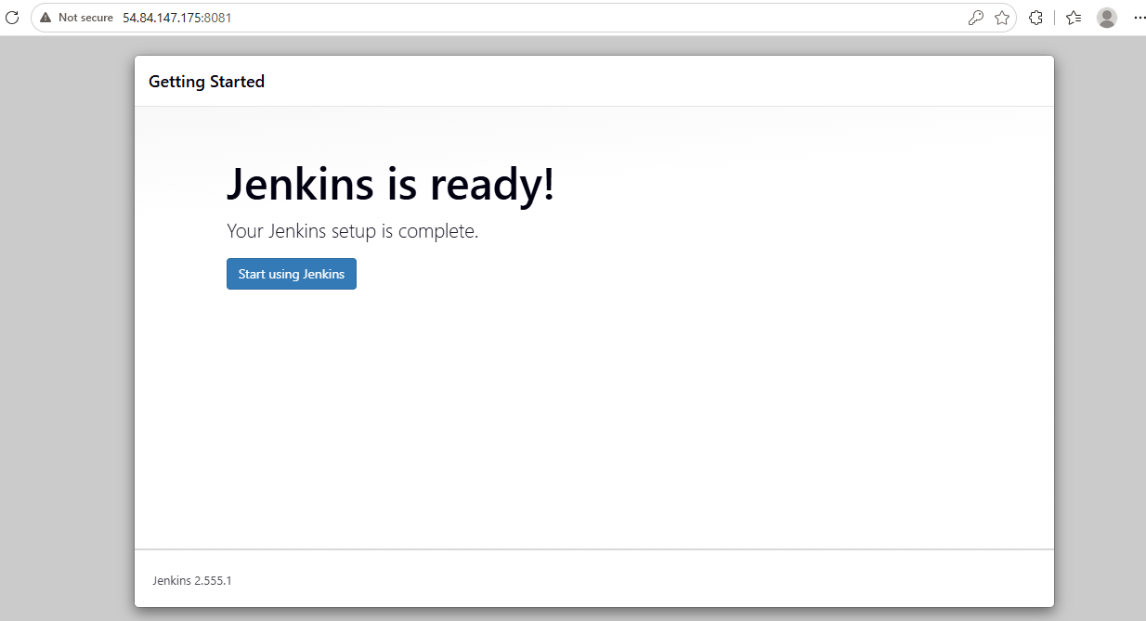
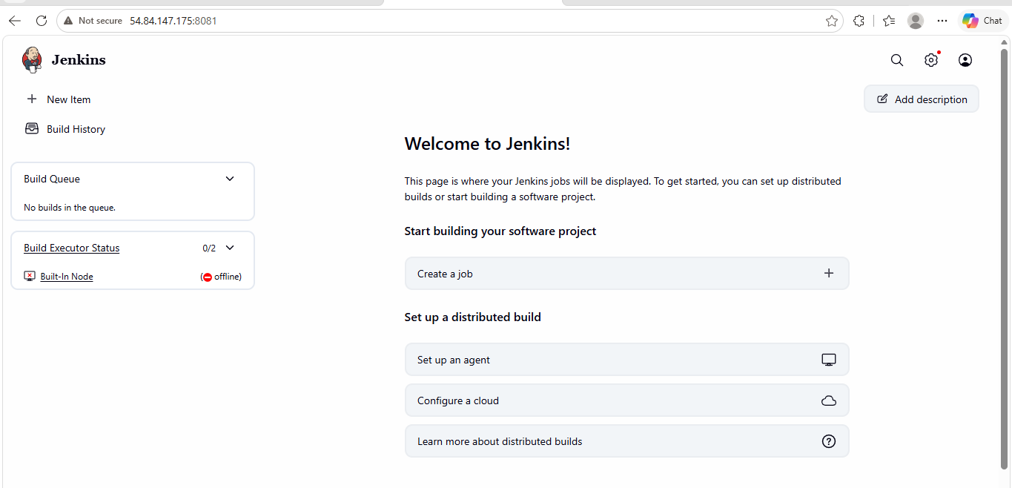
3.Create users called DevOps, Testing in Jenkins with Limited access.
- Create user - Navigate to the Manage Jenkins page from the Jenkins dashboard → Select Users under the Security section.
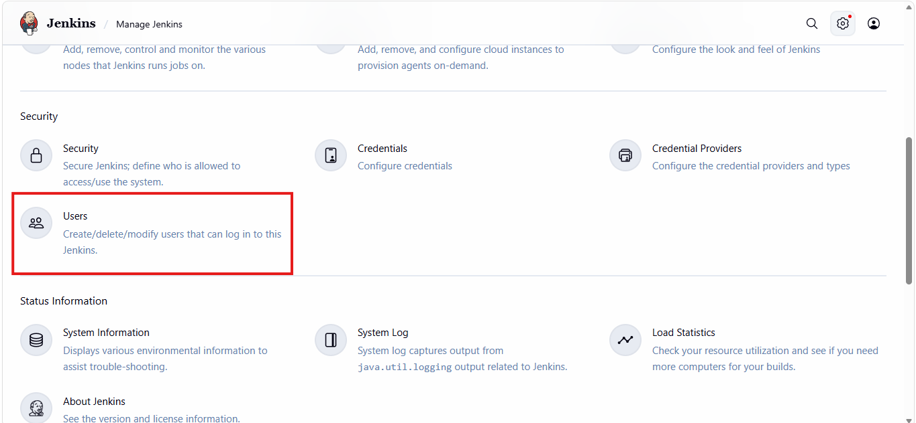
- To create a user - On the Users page, select Create User.
- And created 2 users one is devops and another one is testing.
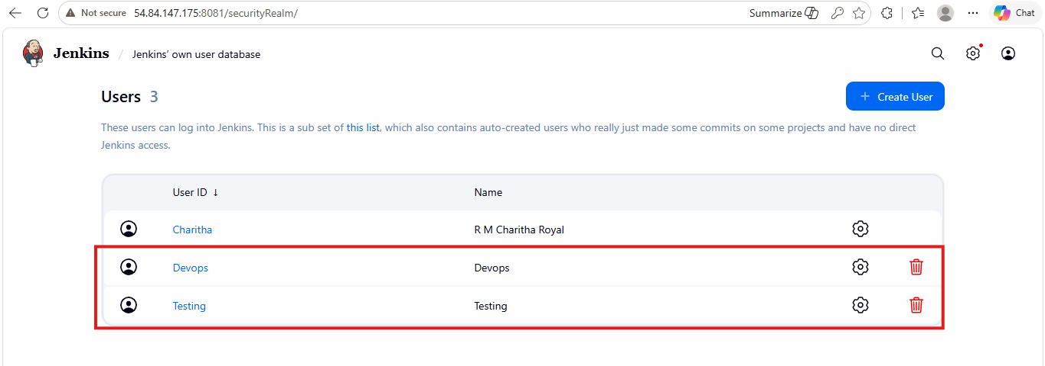
- Go to manage Jenkins and click on plugins
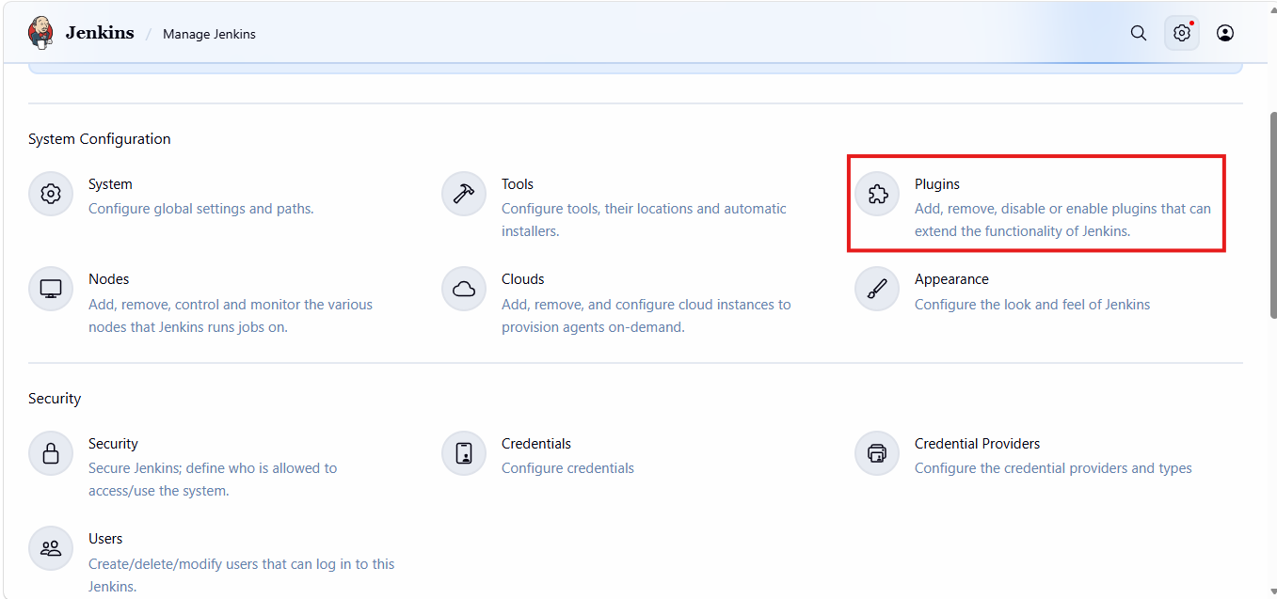
- Click on available plugins
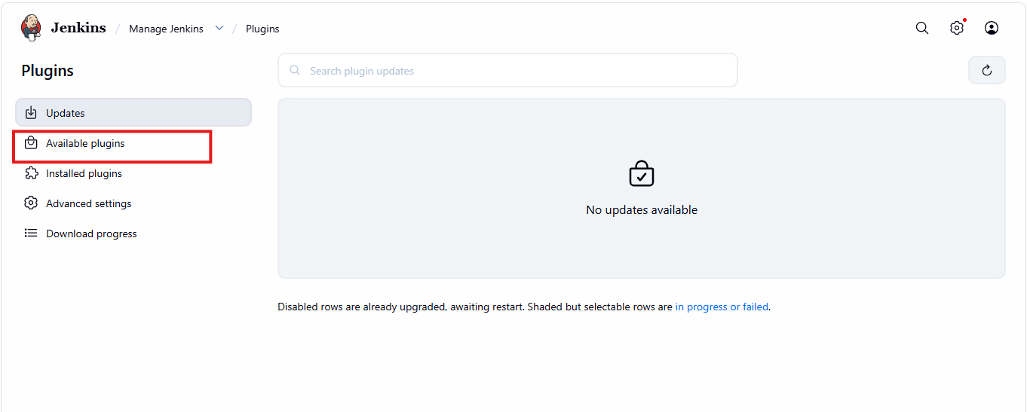
- Search Role-based authorization strategy and install
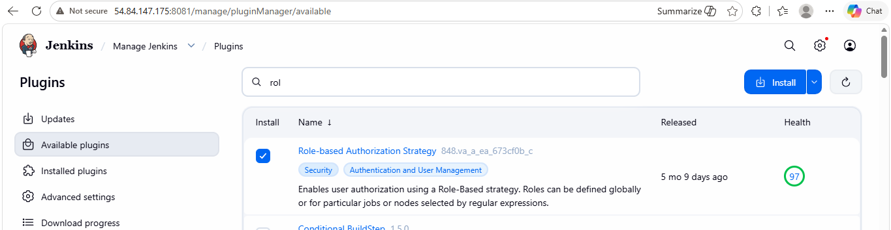
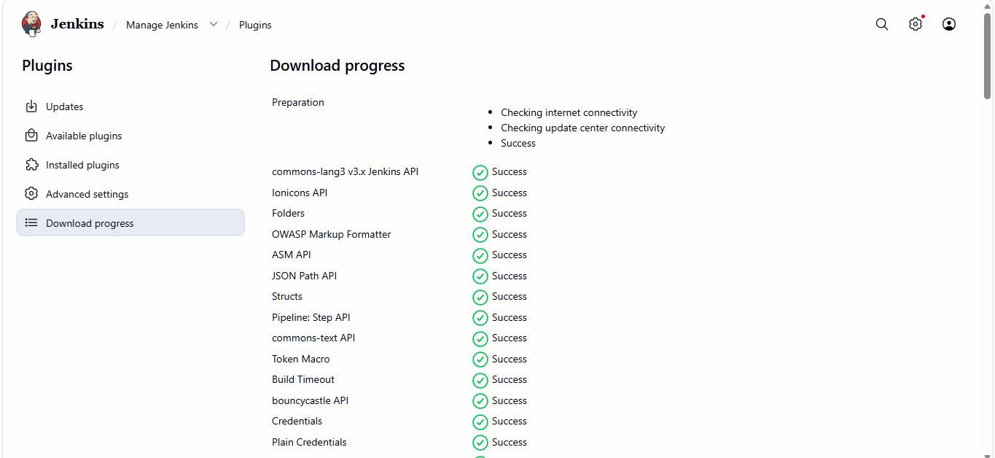
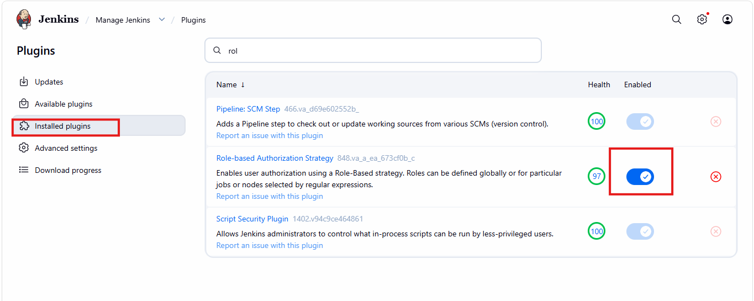
- Enable project based on Jenkins
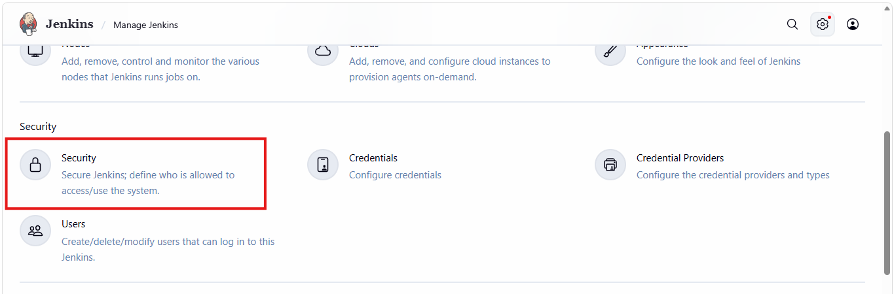
- Under authorization select project based metrix authorization strategy and Assigned roles
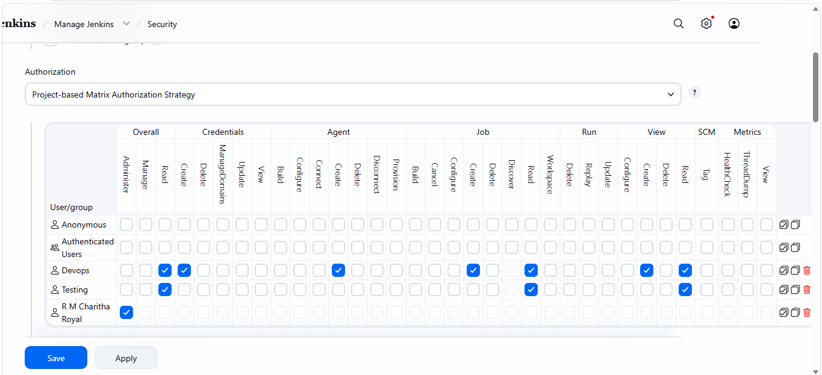
- In DevOps user I am able to create a job as I gave create access
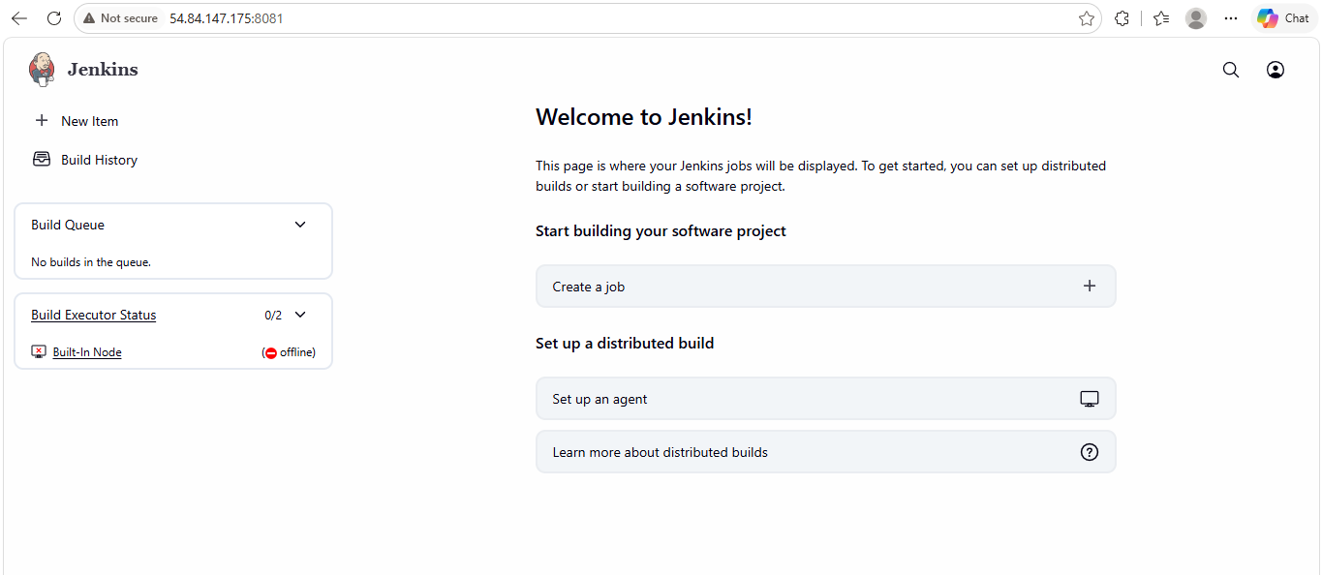
- Tried verifying the user – Testing I am unable to create as I only have read access
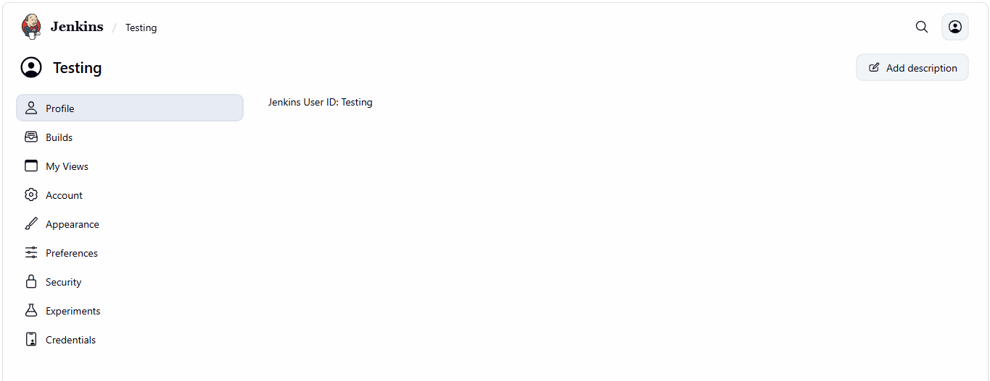

4.Configure labels and restrict the jobs to execute based on label only.
- Go to manage Jenkins and click on nodes
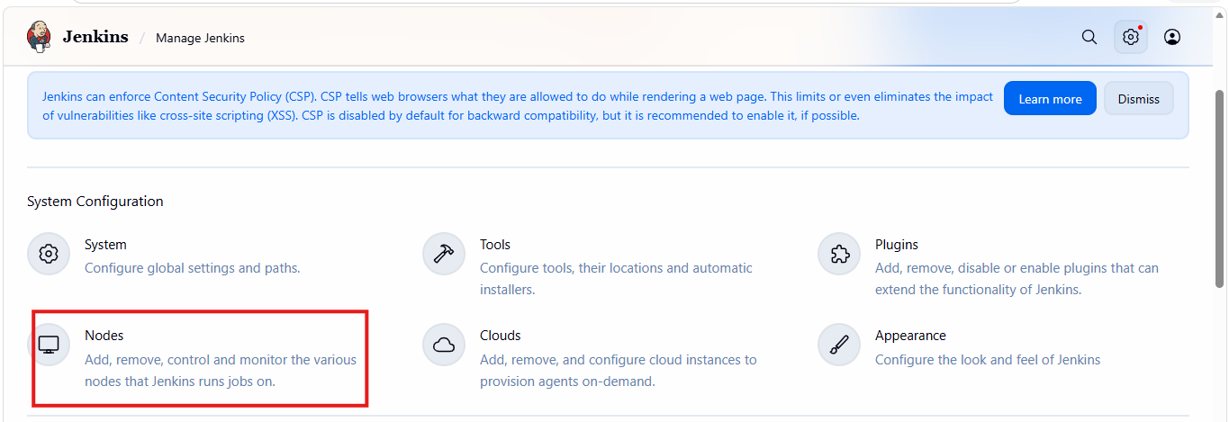
- Click on built in node
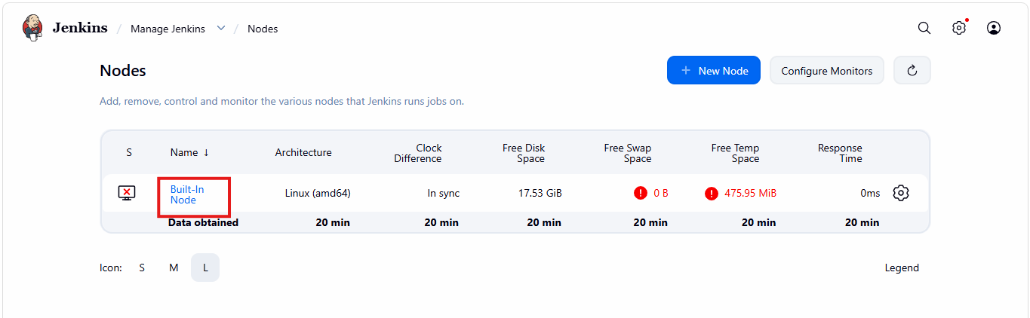
- Click on new item, give item name and choose item type
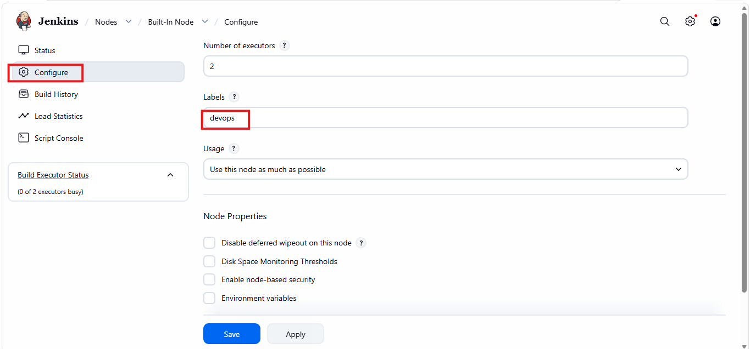
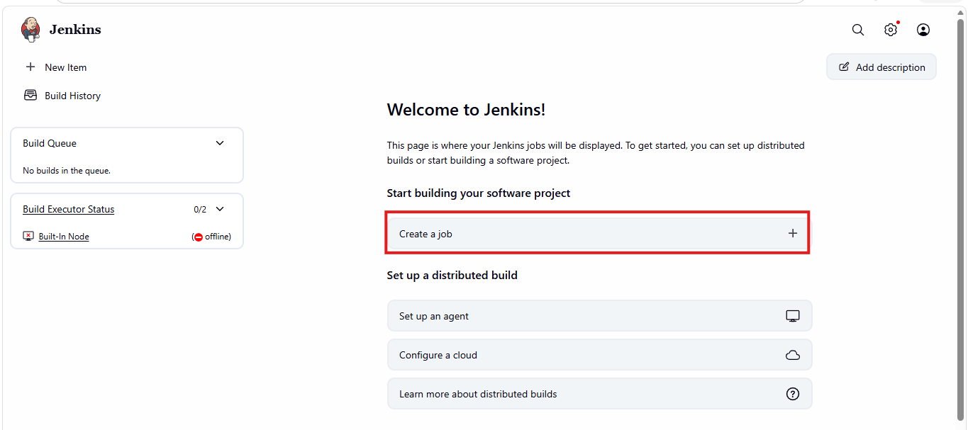
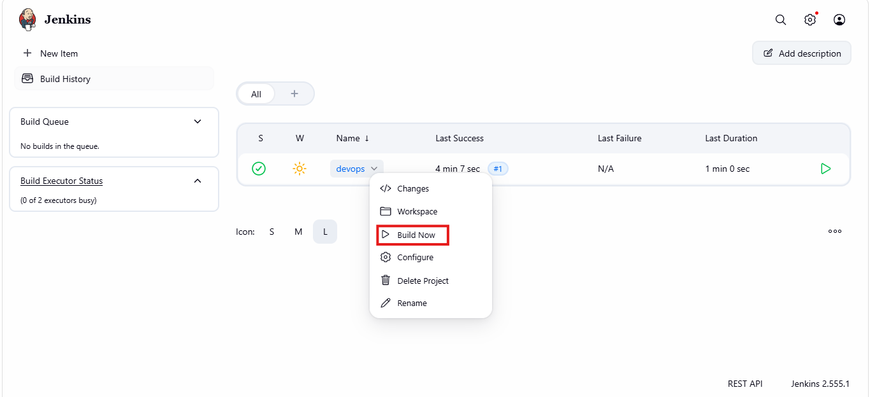
- Increased instances size
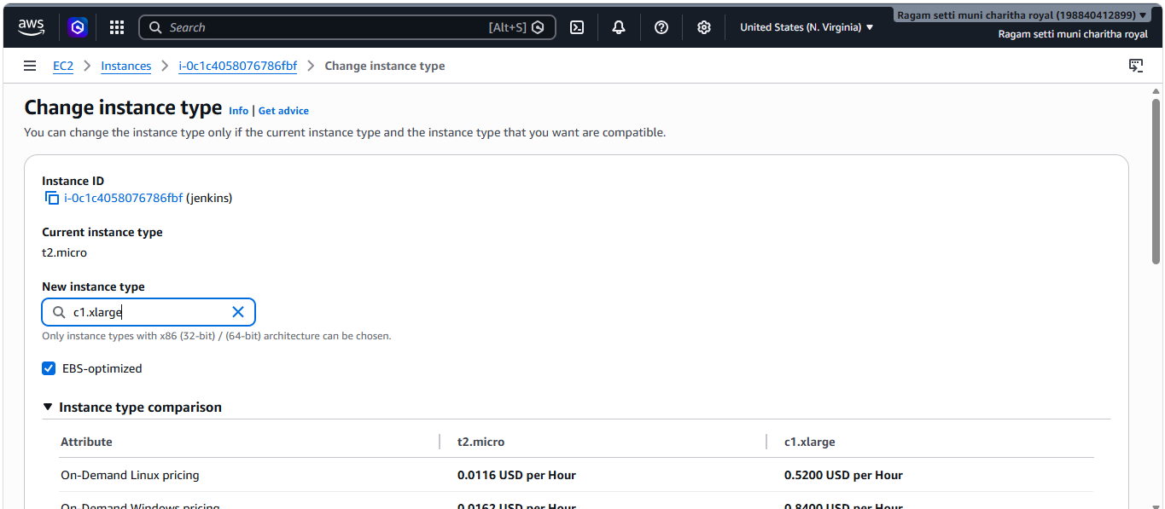
- Gave sleep 60 in build steps to execute shell
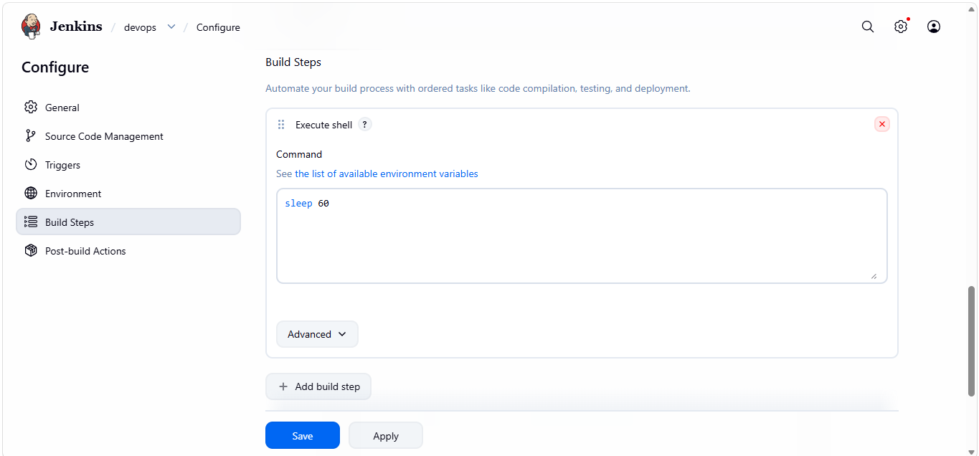
- Status is running successfully
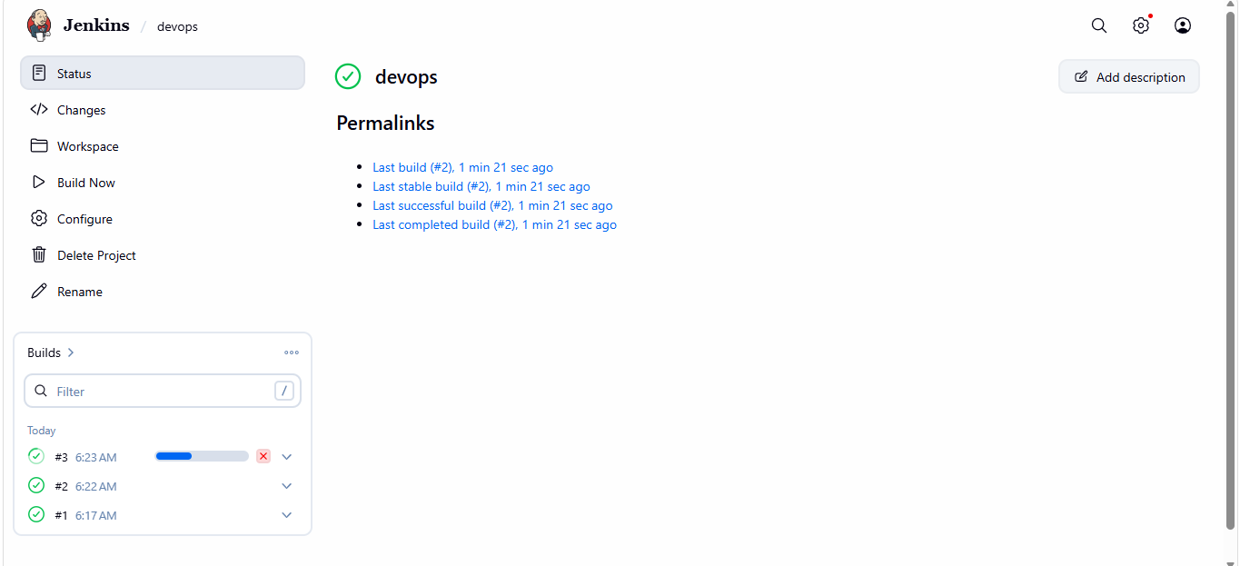
5.Create Three sample jobs using the below URL.
SourceCode:https://github.com/betawins/Techie_horizon_Login_app.git
- Install git plugins in Jenkins server
- Go to Manage Jenkins, Plugins and available plugins
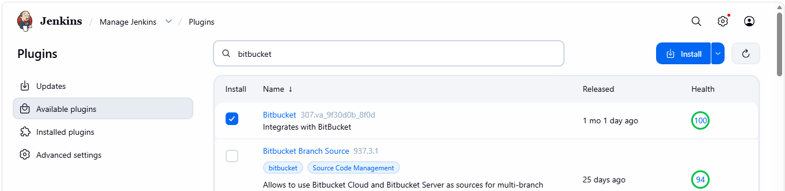
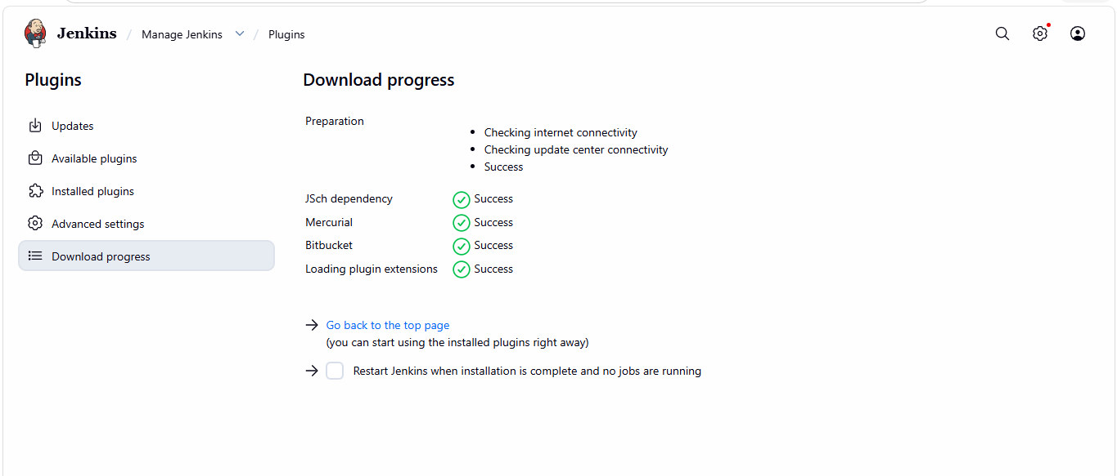
- Install git using Sudo yum install git
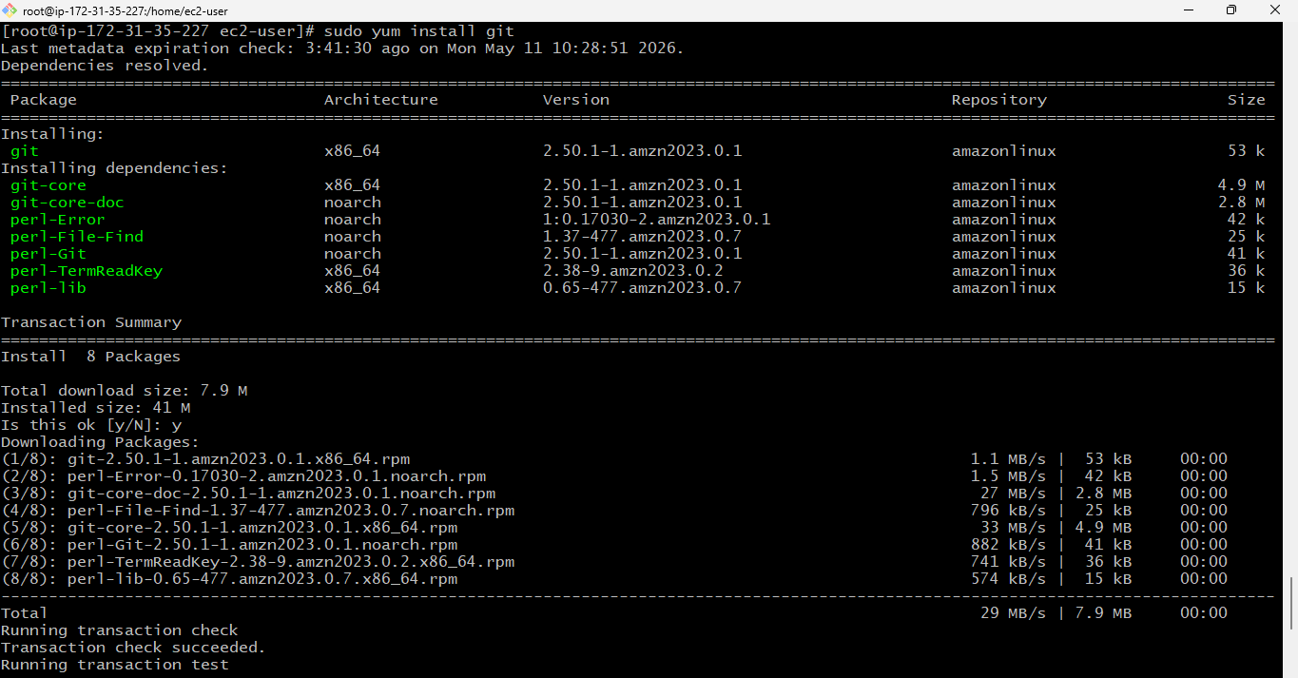
- Create a new item with the name job and gave the git url and click build now
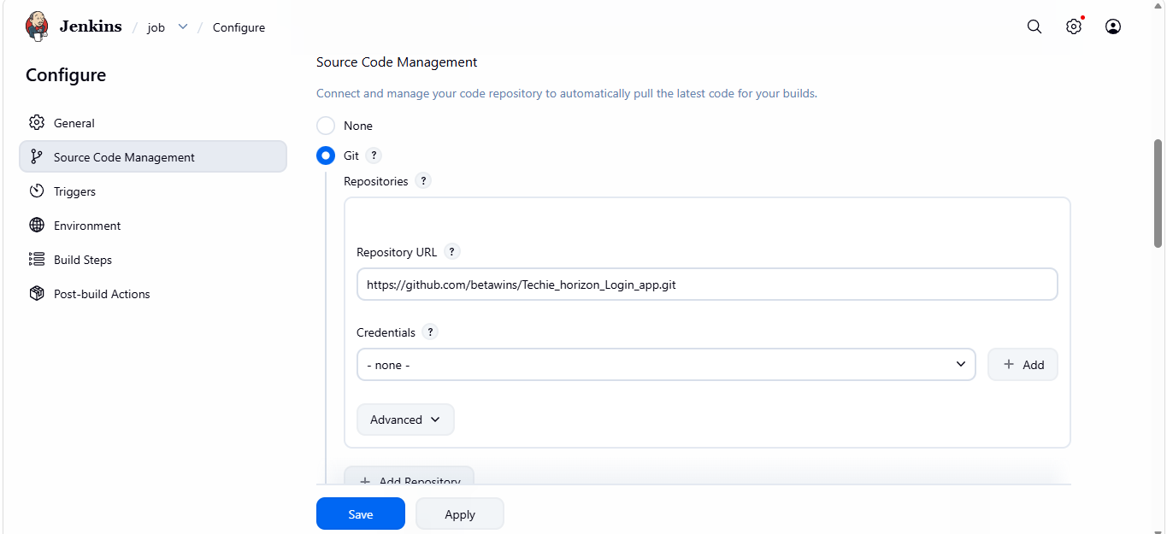
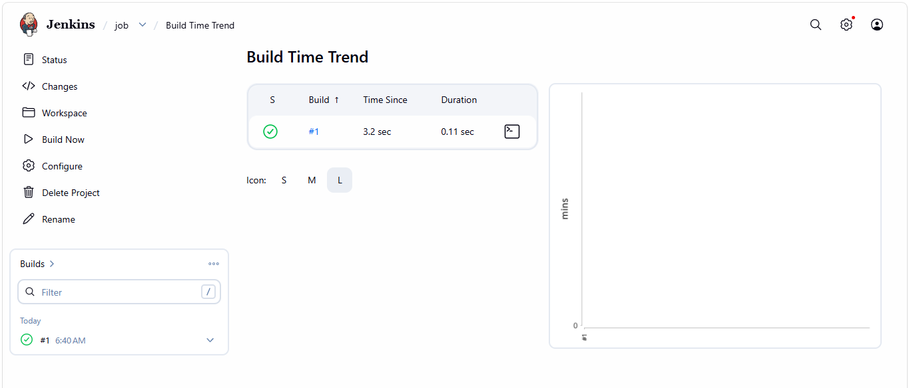
- Go to console output and check the status it is running successfully
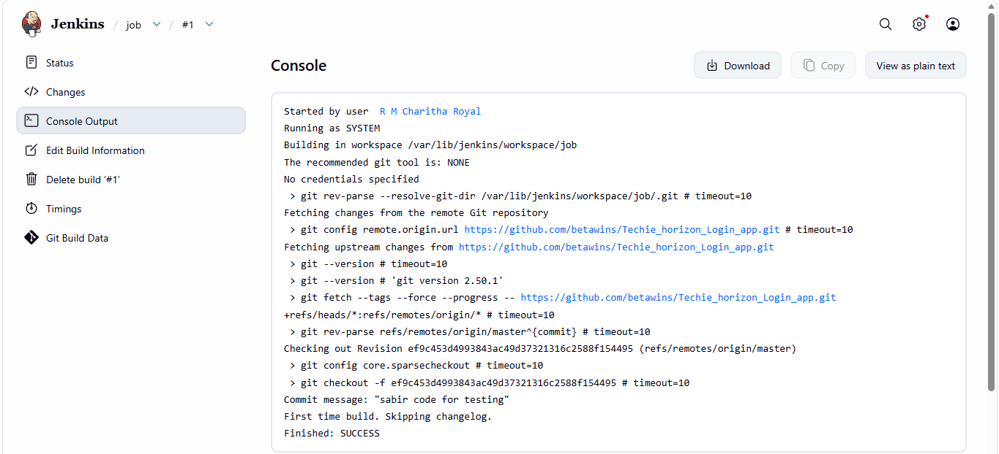
- Create a new item with the name job-1 and gave the git url and click build now
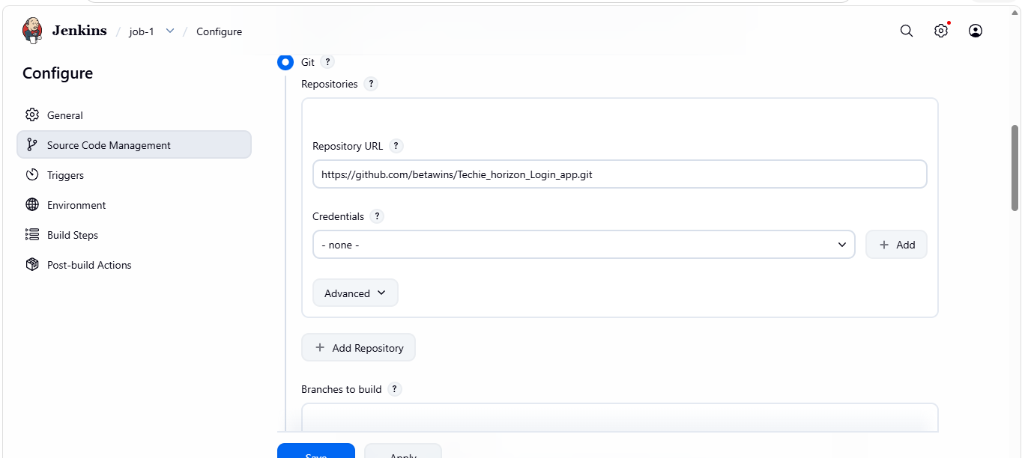
- Gave sleep 30 in build steps to execute shell
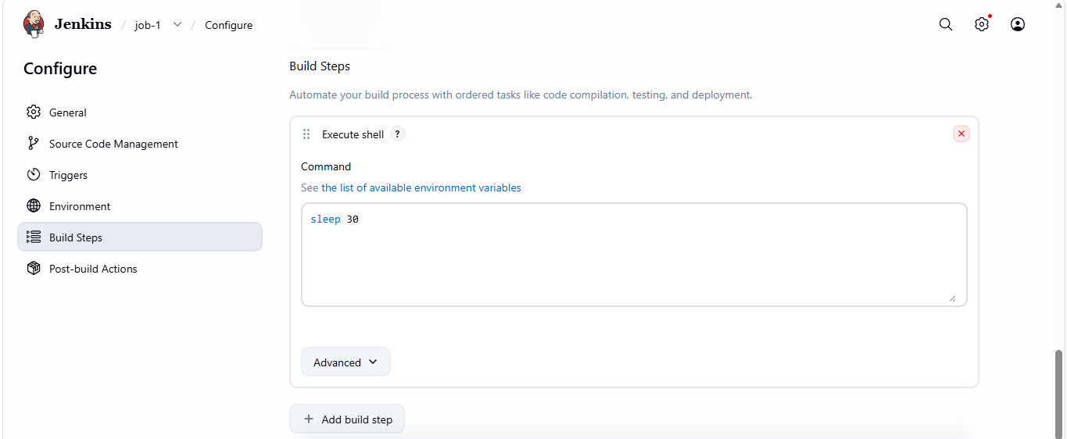
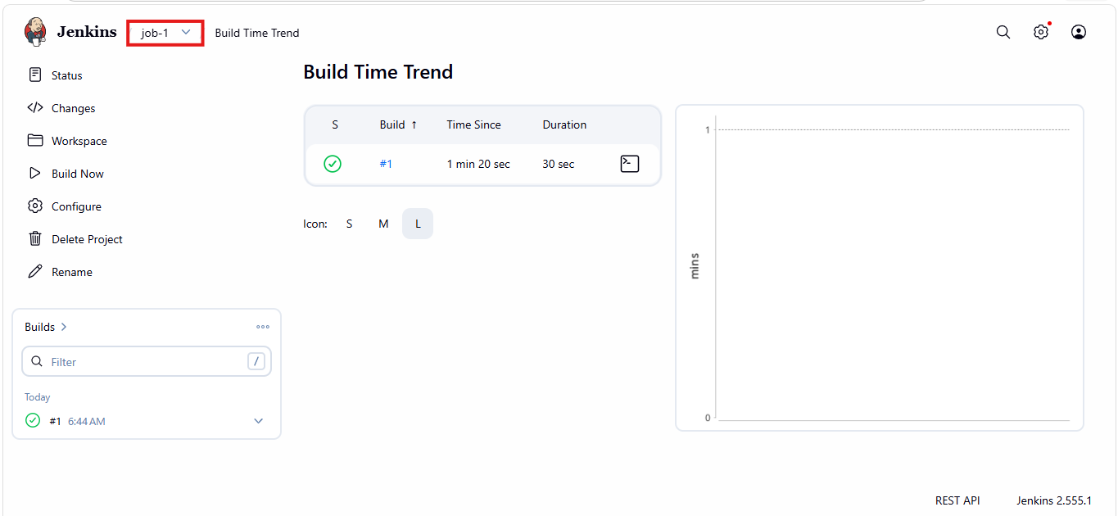
- Go to console output and check the status it is running successfully
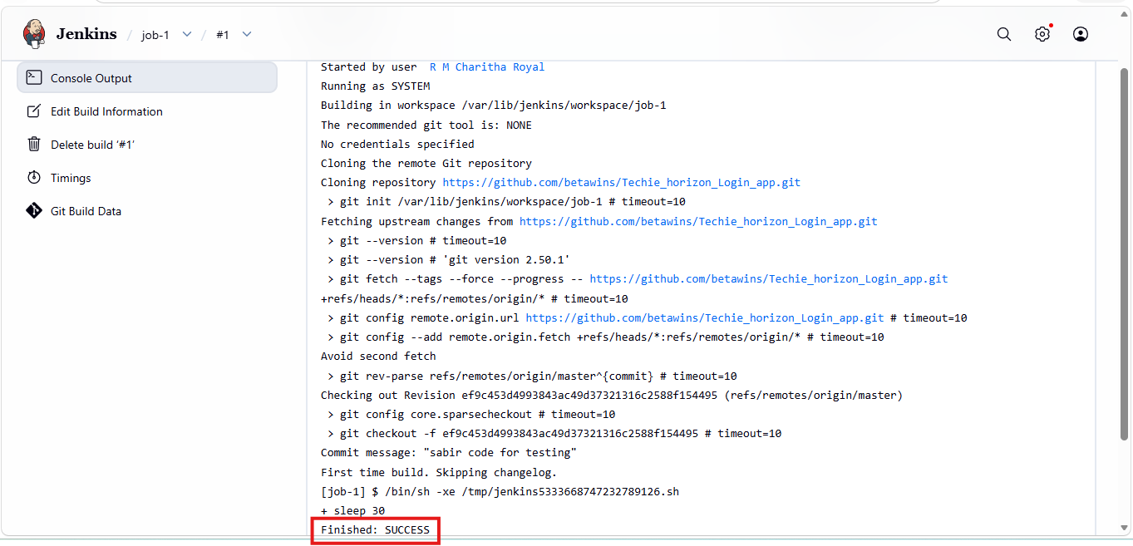
- Create a new item with the name job-2 and gave the git url and click build now
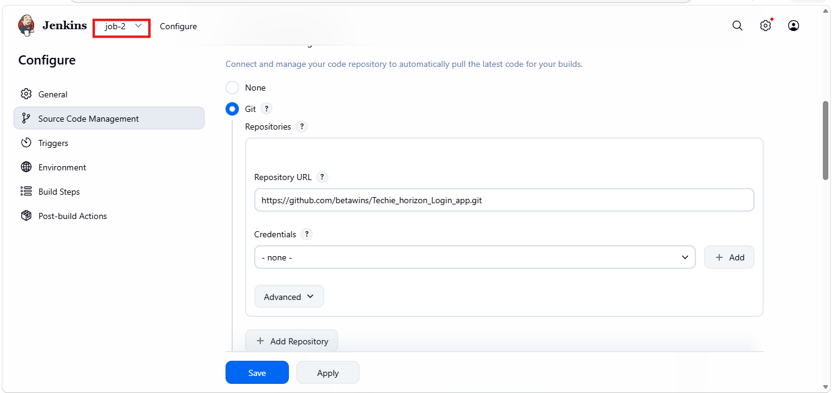
- Gave sleep 60 in build steps to execute shell
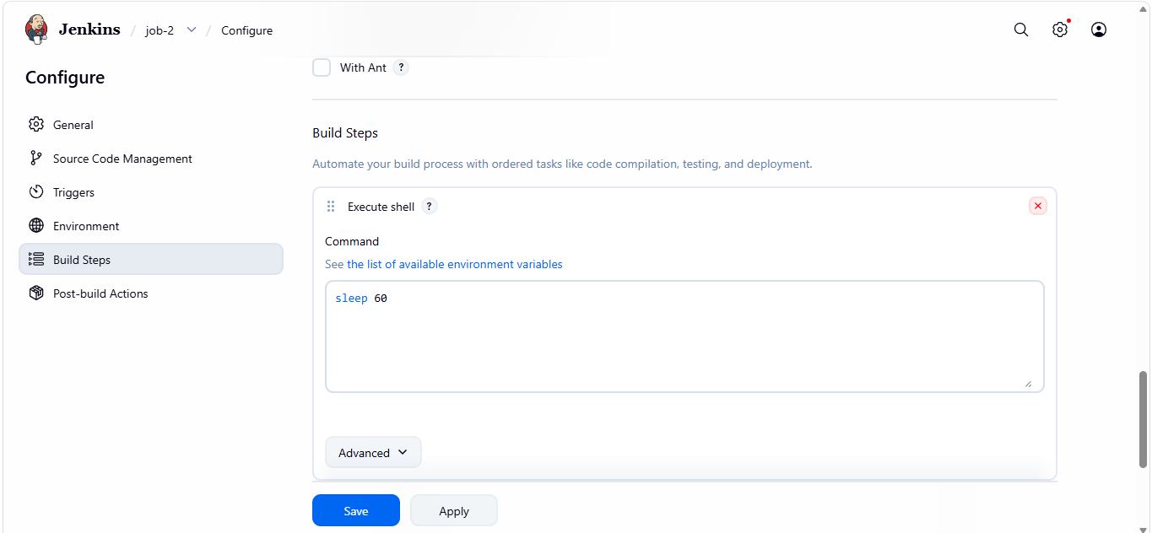
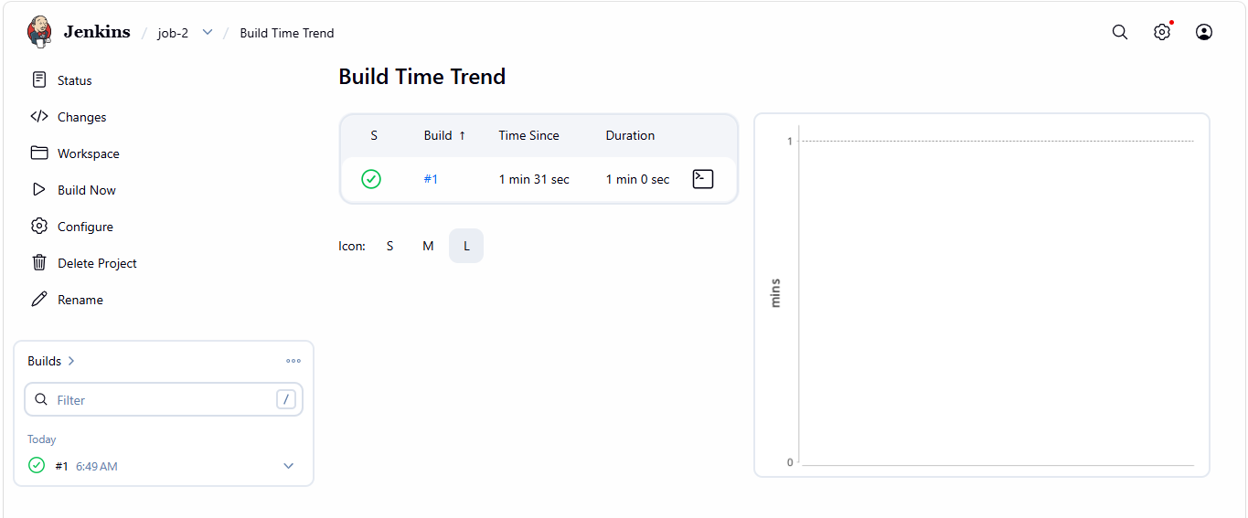
- Go to console output and check the status it is running successfully
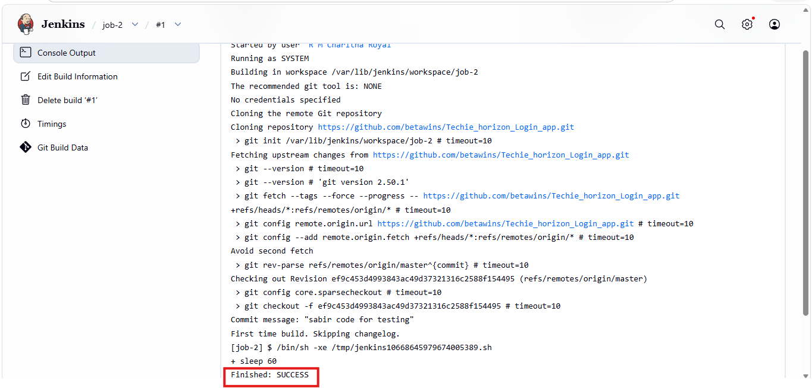
6.Create one Jenkins job using GitHub Private repository.
- Open GitHub and click on new repository and give a name and configuration change public to private
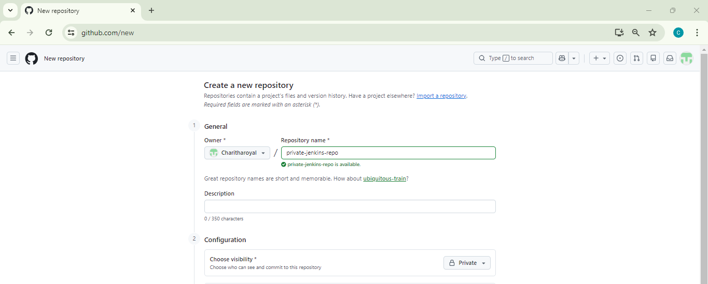
- Navigate to GitHub → Settings → Developer Settings → Personal Access Tokens → Tokens (classic) to create a GitHub personal access token.
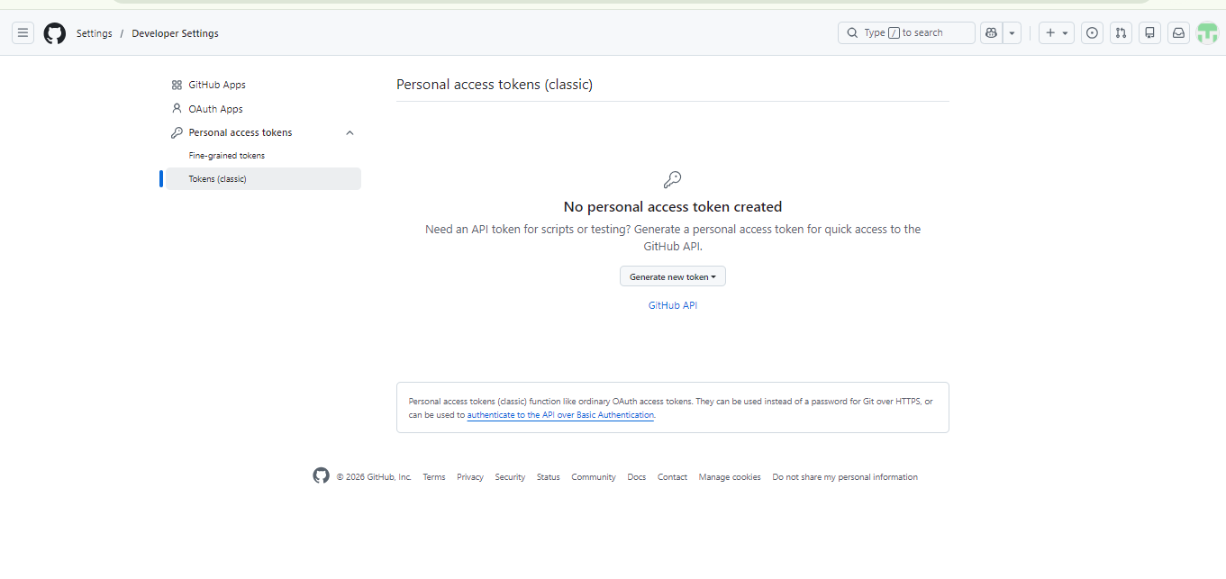
- Click Generate new token → Generate new token (classic) to create a GitHub personal access token for authentication.
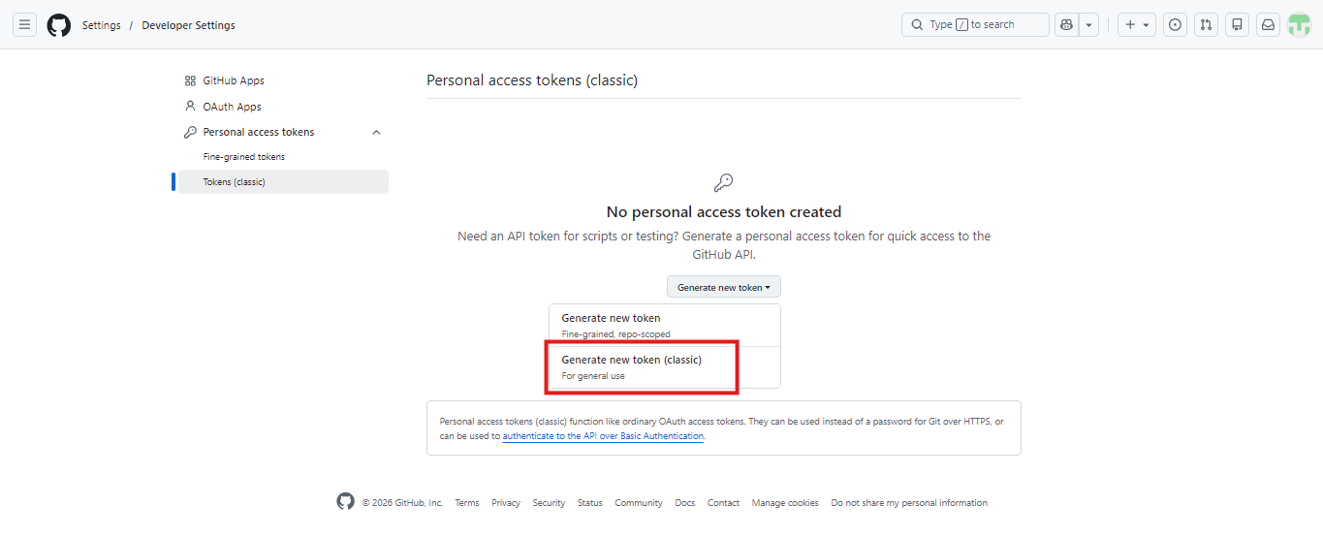
- Enter the token name and select the repo permission to allow Jenkins to access GitHub repositories.
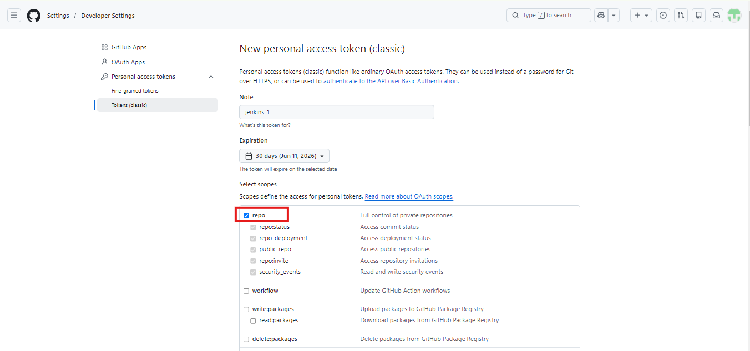
- Go to Manage Jenkins → Credentials to add and manage GitHub credentials securely in Jenkins.
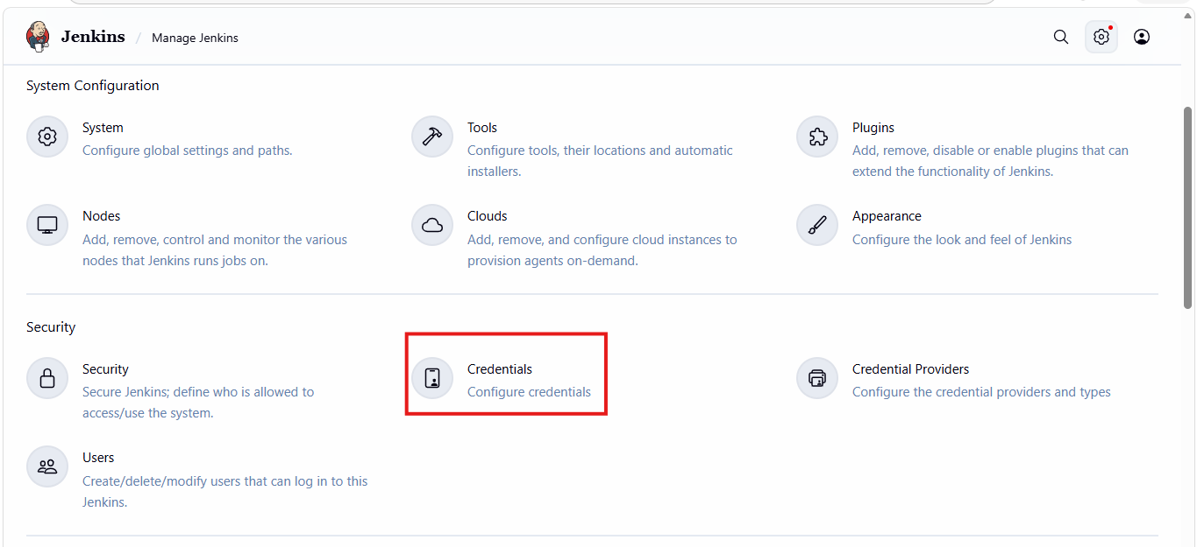
- Select Username with password to store GitHub username and personal access token securely in Jenkins credentials.
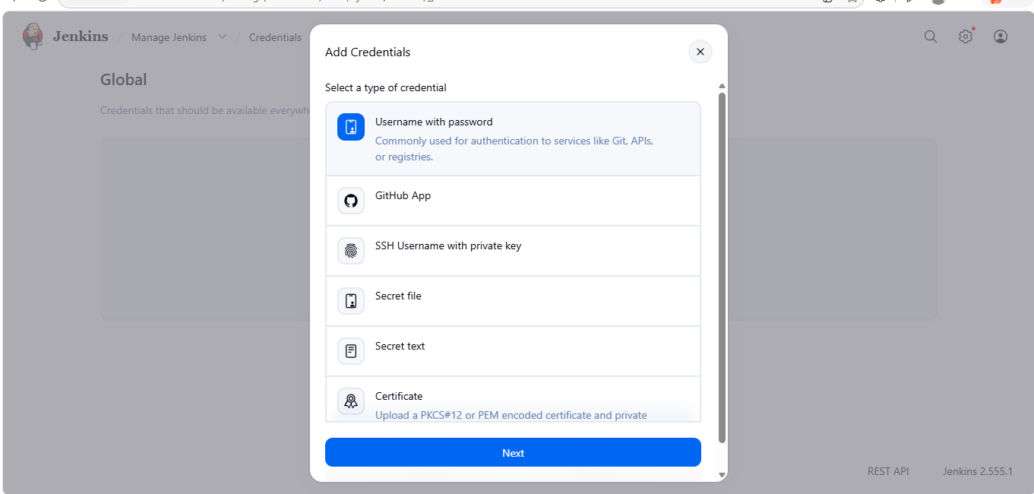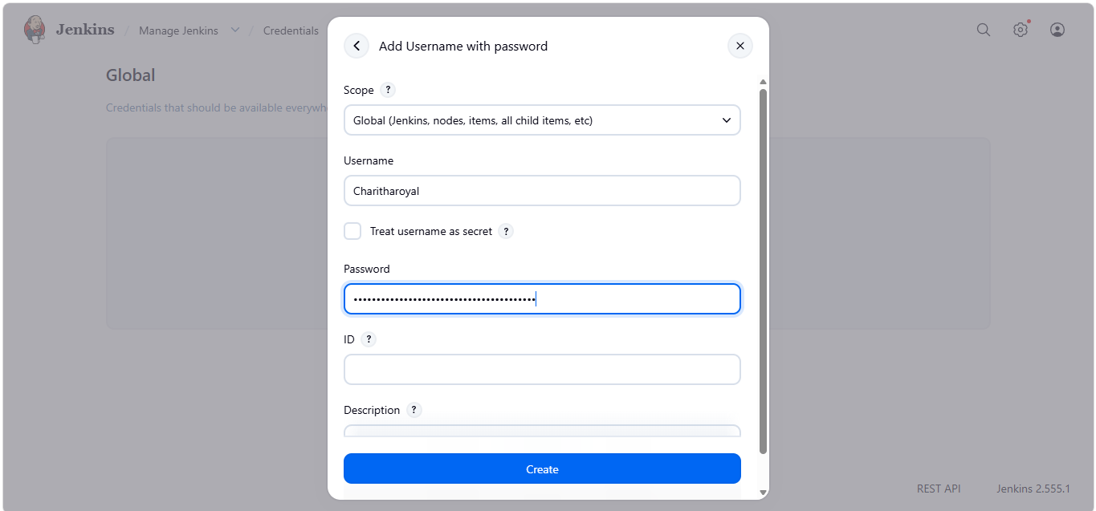
- Enter the job name, select Freestyle project, and click OK to create a new Jenkins job.
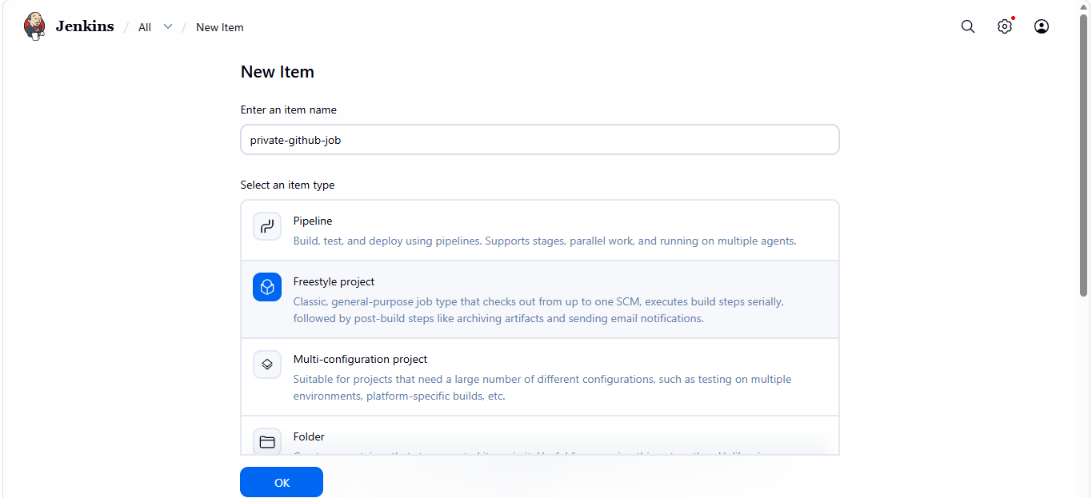
- Enter the GitHub repository URL, select the stored credentials, specify the branch name, and save the Jenkins job configuration.
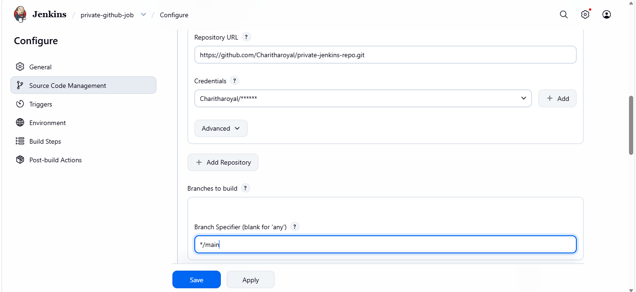
- Go to console output and check the status it is running successfully
